CTF Report
Full Name: Atharva Jagdale
Program: HCS - Penetration Testing 1-Month Internship
Date: 11/03/2025

Category: Web 2.0
Sub-Category: Look Web
Description: The Web 2.0 CTF challenge involved exploring web application security concepts, requiring critical thinking and problem-solving to uncover hidden flaws and achieve the intended objectives.
Challenge Overview: The Look Web CTF challenge required exploring the web application's structure. The flag was obtained by appending /robots.txt to the URL, revealing hidden information that led to the solution.
Steps for Finding the Flag:
- Initial Reconnaissance: Performed basic analysis of the website's structure, identifying accessible endpoints and observing the website's behavior.
- Input Validation Testing: Tested various inputs in URL parameters and forms to check for unusual responses or hidden content.
- Directory Enumeration: Used common directory enumeration techniques and tools to identify /robots.txt as a potential entry point.
- Exploitation: Accessed /robots.txt, which revealed disallowed paths containing critical information.
- Flag Retrieval: Navigated to the disclosed path from /robots.txt and successfully obtained the flag.
Flag: flag{V13w_r0b0t5.txt_c4n_b3_u53ful!!!}
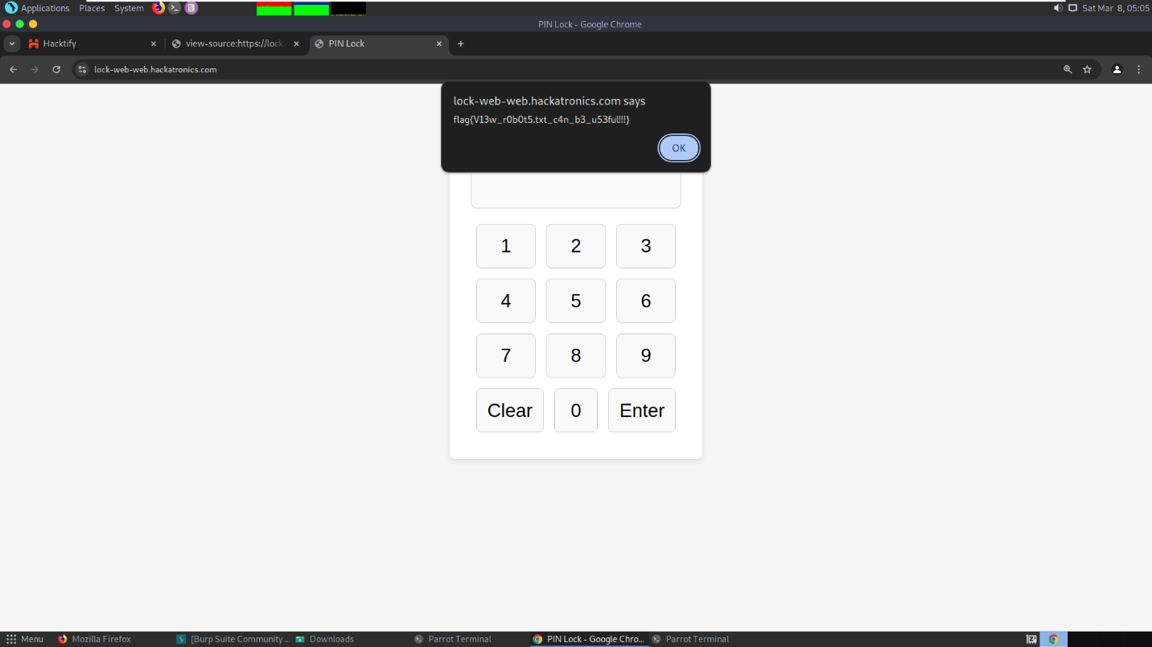
Category: Web 2.0
Sub-Category: The World
Description: The Web 2.0 CTF challenge involved exploring web application security concepts, requiring critical thinking and problem-solving to uncover hidden flaws and achieve the intended objectives.
Challenge Overview: This challenge required identifying hidden paths within the website. By appending /secret.txt to the URL, a concealed file was discovered, ultimately revealing the flag.
Steps for Finding the Flag:
- Initial Reconnaissance: Conducted a thorough analysis of the website's structure, URLs, and page behavior to identify potential entry points.
- Input Validation Testing: Tested various inputs in URL parameters and forms to check for unusual responses or hidden content.
- Directory Enumeration: Performed directory brute-forcing using tools like gobuster or dirbuster, revealing accessible endpoints.
- Exploitation: Accessed /robots.txt, which revealed disallowed paths containing critical information in the encoded format.
- Flag Retrieval: Navigated to the disclosed path from /robots.txt and successfully obtained the flag, followed by decoding the obtained string using base64 decoder tool.
Encoded String: RkxBR3tZMHVfaGF2M180eHBsMHJlRF90aDNfVzByTGQhfQ==
Flag: FLAG{Y0u_hav3_4xpl0reD_th3_W0rLd!}
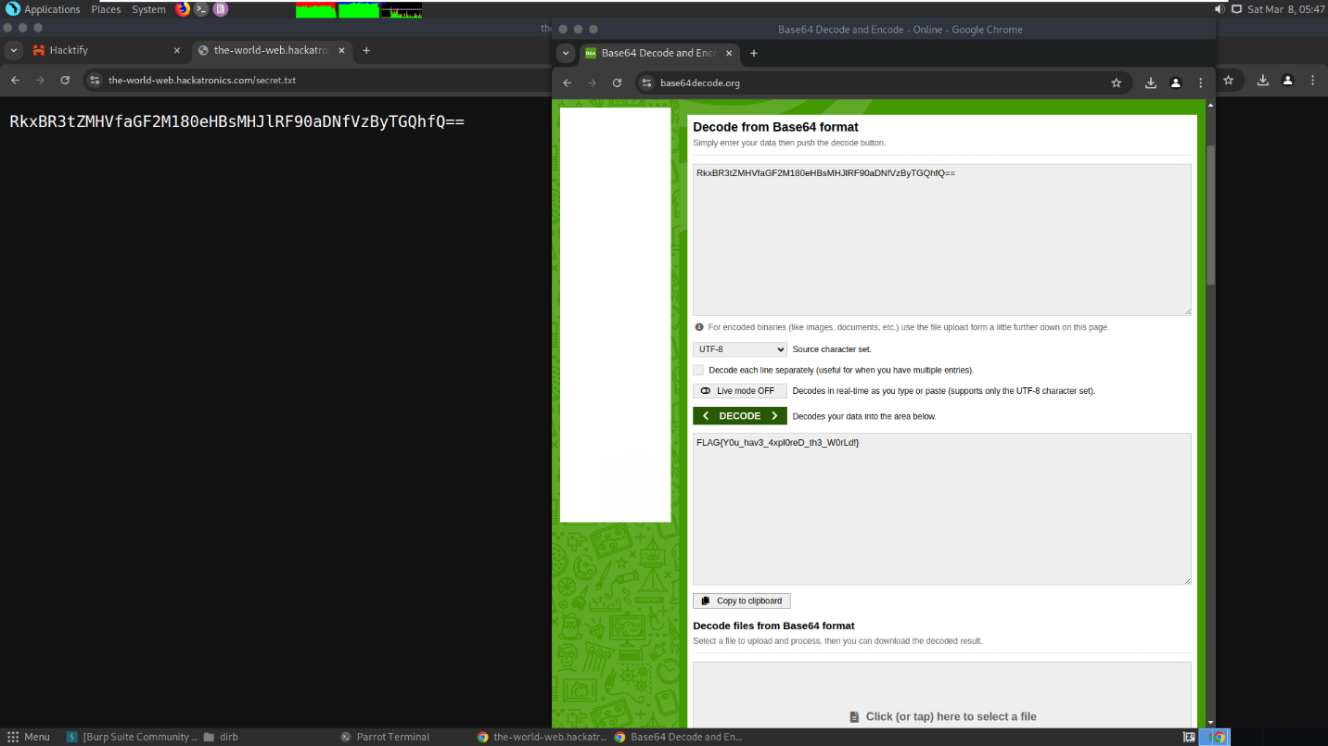

Category: Network Forensics
Sub-Category: Corrupted
Description: The Network Forensics challenge involved analyzing captured network traffic to uncover hidden data. By carefully examining packet details, patterns, and communication flows, the investigation led to the successful extraction of the concealed flag.
Challenge Overview: The challenge involved analyzing a corrupted image file. Using the 'repair.easeus.com' portal, the image was successfully repaired, revealing the hidden flag text embedded within the recovered photo.
Steps for Finding the Flag:
- Initial Reconnaissance: Examined the provided image file and identified that it was corrupted or unreadable.
- Input Validation Testing: Attempted to open the image in multiple viewers to confirm corruption and verify file integrity.
- Directory Enumeration: Explored potential metadata or file details but found no immediate clues.
- Exploitation: Utilized the 'repair.easeus.com' portal to repair the corrupted image file.
- Flag Retrieval: Successfully recovered the image, which revealed the hidden flag text within the restored content.
Flag: flag{m3ss3d_h3ad3r$}
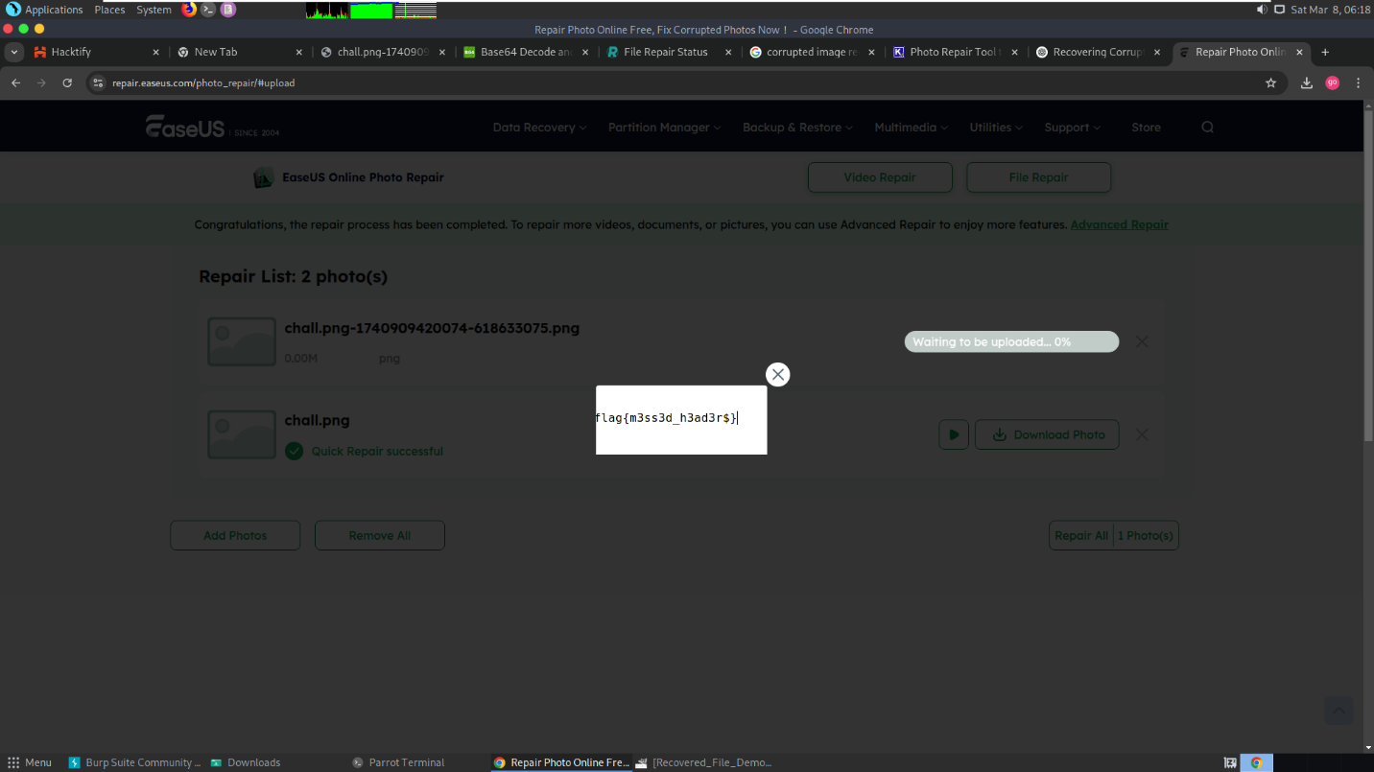

Category: Network Forensics
Sub-Category: Shadow Web
Description: The Network Forensics challenge involved analyzing captured network traffic to uncover hidden data. By carefully examining packet details, patterns, and communication flows, the investigation led to the successful extraction of the concealed flag.
Challenge Overview: Analyzed the provided file using Wireshark, focusing on HTTP POST method packets. Noticed a pattern where each packet contained a changing alphabet. Combined these characters and decoded the resulting string using a Base64 decoder to successfully extract the flag.
Steps for Finding the Flag:
- Initial Reconnaissance: Examined the provided file in Wireshark to analyze network traffic.
- Input Validation Testing: Reviewed the data packets, particularly focusing on HTTP POST requests for any unusual patterns.
- Directory Enumeration: Identified recurring packets with varying data values, indicating potential encoded information.
- Exploitation: Collected the changing alphabets observed in the HTTP POST packets, then combined them to form a meaningful string.
- Flag Retrieval: Decoded the combined string using an online Base64 decoder to successfully retrieve the flag.
Flag: flag{mult1pl3p4rtsc0nfus3s}

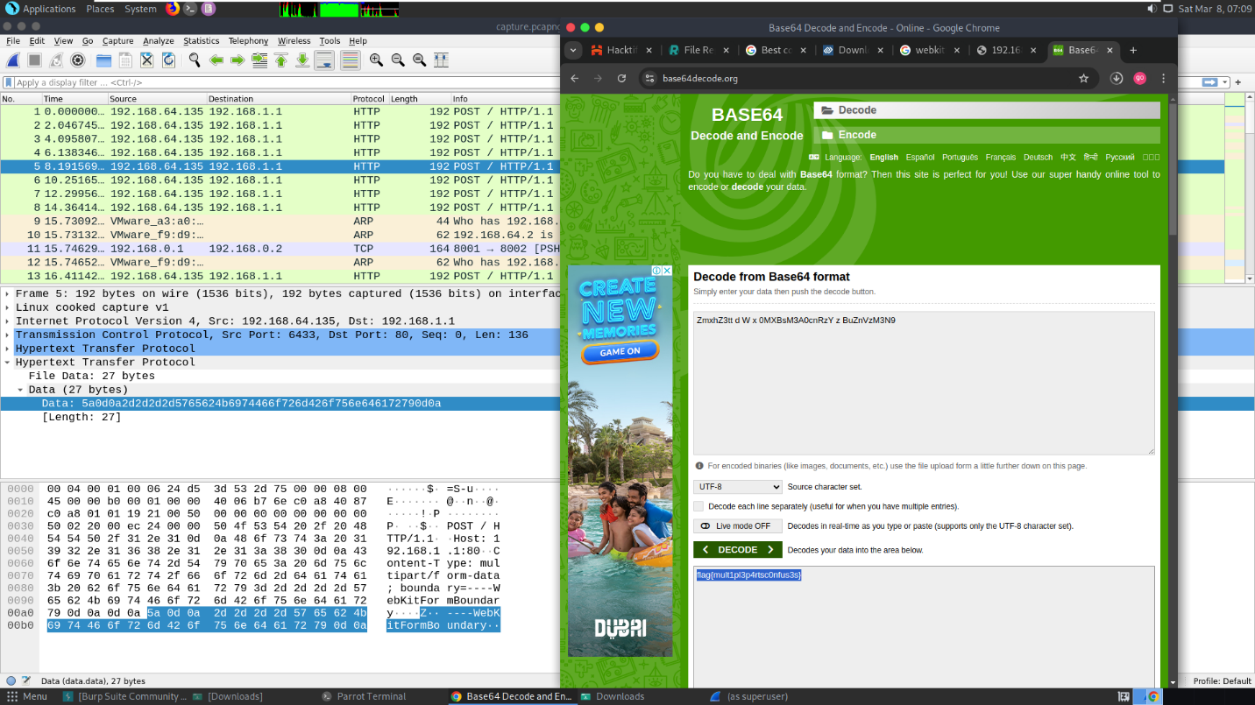

Category: Reverse Engg
Sub-Category: Lost in the Past
Description: The Reverse Engg challenge involved analyzing a compiled binary file to uncover hidden logic and extract the encoded flag by understanding the program's internal structure and behavior.
Challenge Overview: The Lost in the Past challenge required inspecting files within a provided zipped folder. A cipher text hidden in one of the files was decoded using "dencode.com," revealing the FLAG.
Steps for Finding the Flag:
- Initial Reconnaissance: Examined the provided zipped folder and identified multiple files inside.
- Input Validation Testing: Checked the contents of the files for suspicious patterns or encoded text.
- Directory Enumeration: Explored the file structure within the zipped folder to ensure no hidden files were missed.
- Exploitation: Identified a file containing cipher text and decoded it using "dencode.com."
- Flag Retrieval: Successfully decoded the text to reveal the FLAG.
Flag: flag{t00_much_rev3rs1ng}

Category: Reverse Engg
Sub-Category: Decrypt Quest
Description: The Reverse Engg challenge involved analyzing a compiled binary file to uncover hidden logic and extract the encoded flag by understanding the program's internal structure and behavior.
Challenge Overview: The challenge involved extracting a ZIP file containing a text string that, when decoded using Base64, revealed a Java program. Running the program required an input derived from a hint in the provided Drive URL. The encoded string from the Drive URL was decoded using a Brainfuck decoder, ultimately revealing the FLAG.
Steps for Finding the Flag:
- Initial Reconnaissance: Downloaded the provided ZIP file and examined its contents.
- Input Validation Testing: Identified a text file within the ZIP folder containing a Base64 encoded string.
- Directory Enumeration: Found a Drive URL mentioned as a hint, indicating additional information.
- Exploitation: Decoded the Base64 string to reveal a Java program. Ran the Java program, which required an input. Decoded the encoded string from the Drive URL using a Brainfuck decoder to derive the required input.
- Flag Retrieval: Successfully entered the decoded value into the Java program, revealing the FLAG.
Flag: flag{hjwilj111970djs}

Category: OSINT
Sub-Category: Time Machine
Description: The OSINT challenge involved gathering publicly available information through various online platforms, analyzing clues to uncover hidden data, ultimately leading to the FLAG.
Challenge Overview: The Time Machine challenge required investigating archived web data. By searching 'Mr. TrojanHunt travel time' on Google and exploring results on Archive.org, the FLAG was located inside a secret.txt file in the archive links.
Steps for Finding the Flag:
- Initial Reconnaissance: Conducted a Google search using the keywords 'Mr. TrojanHunt travel time'.
- Input Validation Testing: Analyzed search results to identify relevant links and references.
- Directory Enumeration: Explored Archive.org for potential archived content related to the search query.
- Exploitation: Accessed the links: https://archive.org/details/secret_202103.
- Flag Retrieval: Found the secret.txt file in the directory path https://dn790008.ca.archive.org/0/items/secret_202103/secret.txt containing the FLAG.
Flag: flag{Tr0j3nHunt_t1m3_tr4v3l}

Category: OSINT
Sub-Category: Snapshot Whispers
Description: The OSINT challenge involved gathering publicly available information through various online platforms, analyzing clues to uncover hidden data, ultimately leading to the FLAG.
Challenge Overview: Revealed the FLAG by identifying the provided image using Google Lens, which pointed to the Sydney Opera House. Further investigation on Google Maps, filtering reviews with the keyword 'concert hall', provided the necessary clues.
Steps for Finding the Flag:
- Initial Reconnaissance: Analyzed the provided image and used Google Lens for identification.
- Input Validation Testing: Verified the identified location as the Sydney Opera House.
- Directory Enumeration: Conducted a Google Maps search for the Sydney Opera House and filtered reviews using the keyword 'concert hall’.
- Exploitation: Explored filtered reviews to gather relevant clues and information.
- Flag Retrieval: Identified the required details in one of the reviews, successfully obtaining the FLAG.
Flag: flag{jeffrey_seidman}

Category: Crypto
Sub-Category: Wh@t7he####
Description: A cryptography-based challenge requiring decoding an encrypted text using specific ciphers and decryption techniques to uncover the hidden FLAG.
Challenge Overview: The challenge involved decoding an encoded string using the "ReverseFuck decoder," which successfully revealed the hidden FLAG.
Steps for Finding the Flag:
- Initial Reconnaissance: Analyzed the provided encoded string to identify the type of cipher used.
- Input Validation Testing: Tested various decoding methods to determine the correct decryption technique.
- Directory Enumeration: Explored available online decoding tools for potential solutions.
- Exploitation: Used the "ReverseFuck decoder" to decode the given string.
- Flag Retrieval: Successfully obtained the FLAG from the decoded output.
Flag: flag{R3vers3ddd_70_g3t_m3}

Category: Crypto
Sub-Category: Success Recipe
Description: A cryptography-based challenge requiring decoding an encrypted text using specific ciphers and decryption techniques to uncover the hidden FLAG.
Challenge Overview: Solved the challenge by fixing syntax issues in the provided Chef code, compiling it using an online Chef compiler, and decoding the resulting output with a BrainFuck decoder to retrieve the FLAG.
Steps for Finding the Flag:
- Initial Reconnaissance: Reviewed the provided Chef code and identified multiple syntax errors.
- Input Validation Testing: Analyzed the structure of the Chef code to ensure correct formatting and logic.
- Directory Enumeration: No directory enumeration was required for this challenge.
- Exploitation: Corrected the grammatical and syntax errors in the Chef code and compiled it using an online Chef compiler.
- Flag Retrieval: Decoded the compiled output using an online BrainFuck decoder, successfully obtaining the FLAG.
Flag: flag{y0u_40+_s3rv3d!}

